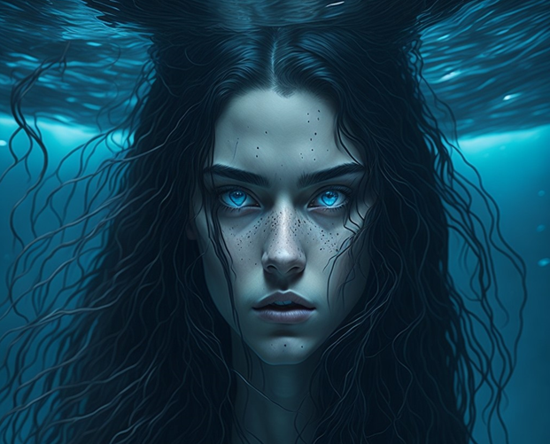 TIMES HARMONY

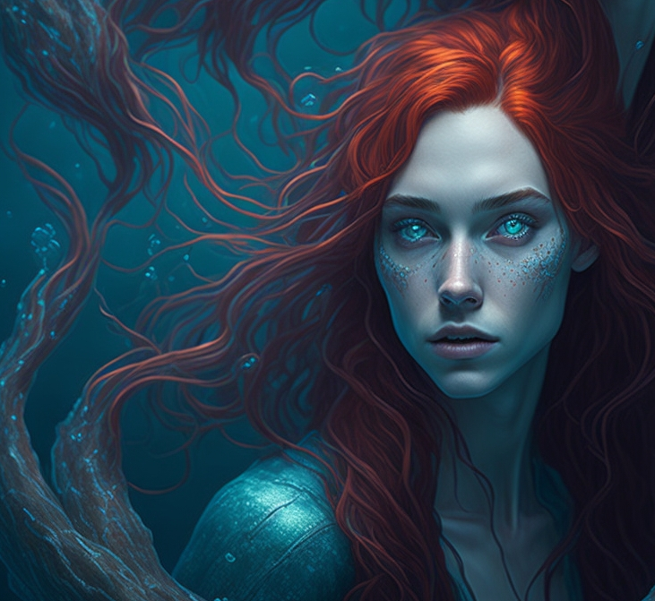
(Mira)

Narrator’s Note:

I sat bolt upright in bed! Aw boy.... here we go again! I thought, wiping my sweat-covered brow….
Truthfully, I doubt these surreal, unusual dreams will continue forever! I do sense they are coming to an end; however, until they do, their clarity leaves me spellbound… and exhausted! They are so unpredictable. The only thing I know for sure is, these dreams occur at times when the moon is completely full! Perhaps there is a link between my dreams and the full moons. Indeed, I have learned that the ocean is immensely tied to the lunar phases, so it’s not surprising they are interconnected. Perhaps the best way to describe my dreams however is to get on with what I pray is our final story…. Times Harmony.
I dearly hope….

Chapter 1 The Four Worlds

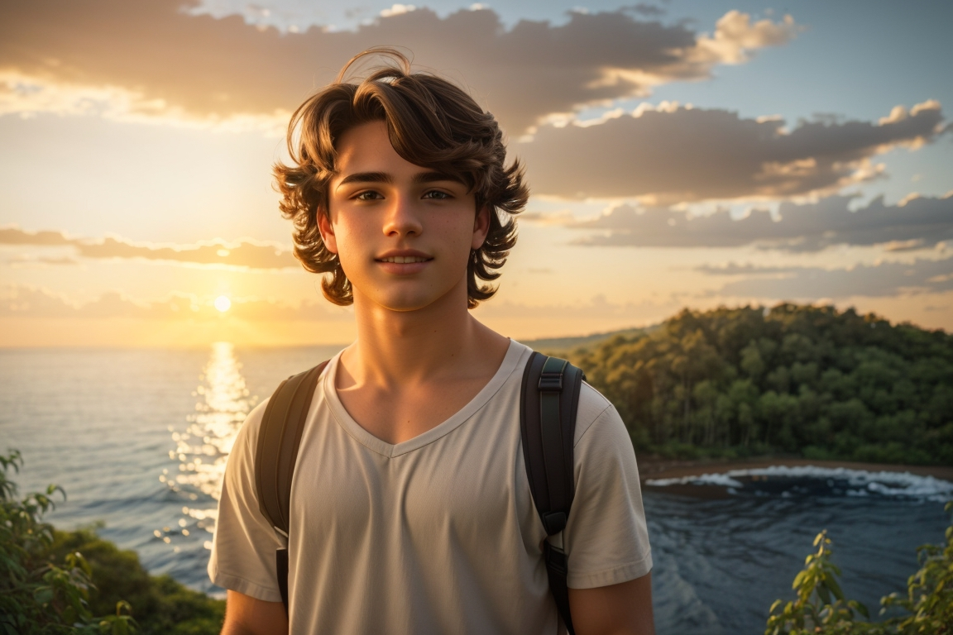
Imagine a world that exists all around us, but no one is aware of it. Then imagine a select few who do know, and, have known for about it for a very, very long time.
They’d understand at the very least that there are three worlds we know of. The world of the sky. The world of the land, and the world of the water. They may also know that these worlds only meet in one place, and that is the shoreline, the place where all three worlds actually touch. They may also realize that there is the potential for another world. A world that allows for travel between these three worlds. The portal world, some would say. A fourth world.
The fourth world allows the traveler to travel through time, from place to place. Distant visitors to our magnificent planet use this other place regularly as a portal, or loop in time, extending from world to world. Don’t ask me how, for no one is exactly sure of …. how.

In this final book, I decided it best to start off with Loretta. For if anyone knows, it would be her. After all, Loretta wasn’t just a human and later, a person-of-the-water, a merperson per-se. She was a survivor, and a tough one at that. Let’s take a look, briefly, at her amazing story, and her turbulent origins as they relate to Jack, Noah, Shannon, and her equally inspiring sister, Mira, as we roll into this, our final book….

Loretta’s story….

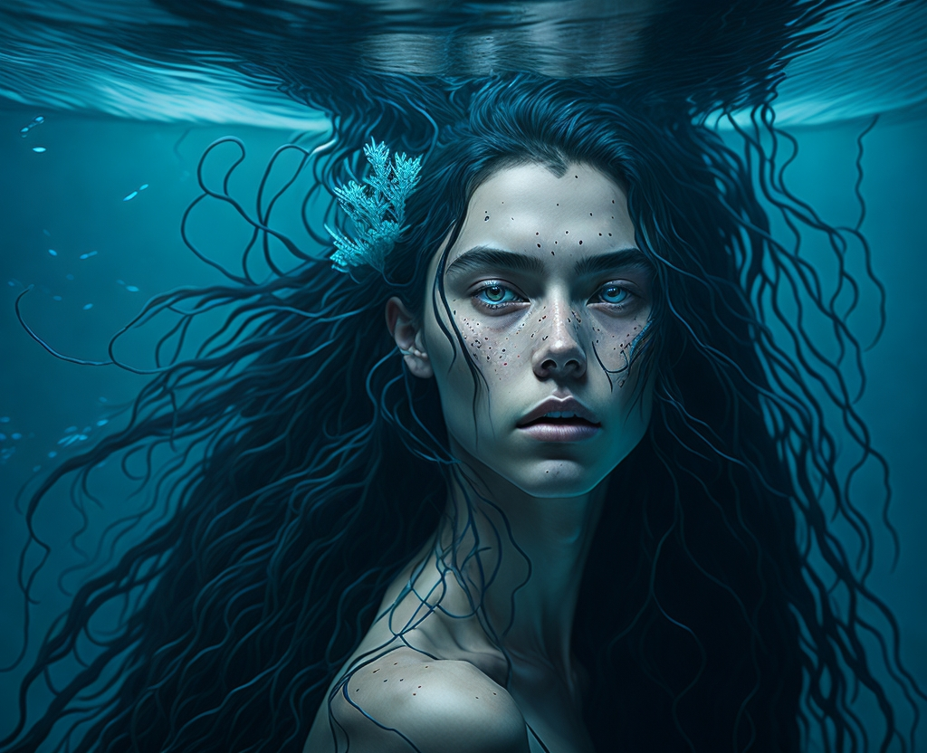

“If I was to claim to be brave, everyone around me in my village would know it to be a lie. I was scared almost every day of my life, especially for my sister, for she was the spirited one to say the least. Me, well I just wanted to survive! Of course, my village is now long gone and so is my blood-family. But how could I be brave, if brave meant working in the fields while my little sister remained home alone? Unprotected? The truth is…. I do have a secret. It’s a secret that for years I was afraid to share simply because…. wait. Perhaps I’ll release this secret later, towards the end of my story when we know each other a little better….”

“I can honestly say I’m probably the most protective big sister there ever was. I do miss her sometimes… Of course, in human years that would make her well over one hundred forty years old now, and we all know that is not possible, so perhaps I’ll leave the rest of that to your imagination. I vividly remember the day this story began….”
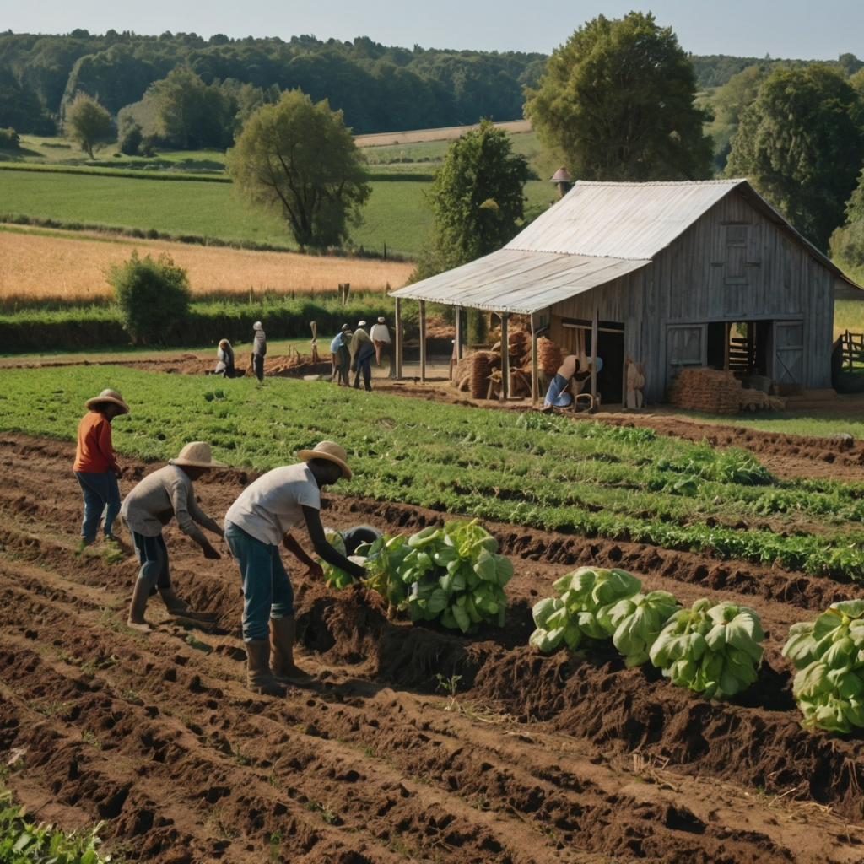

“Back in Ireland my family had been living on potatoes and barley for as long as I could remember. My dad worked in the mines until his hands were raw. Finally, pneumonia wrapped its dark fingers around him. From then on, it was just my mother, but her sadness eventually overtook her as quickly as did the same disease. My mother had done her best to look after the family of a powerful lord, who ruled over the countryside. Literally running across the countryside, she would race back to look after us, her family during her breaks, and I remember her showing up exhausted at the end of the day, her hair unkempt and fatigue in her eyes. Nonetheless, she loved us until the end.”

“Strangely enough, a sailorman, named Seth was always somewhere nearby, walking through a crowd or watching from a balcony above. Whenever he had the opportunity, I could feel his cold eyes watching my family and I, and I’m sure my dad had known of his presence earlier as well. Looking back, I believe it was Seth who kept my father working in the mines and continually made life frustrating for us. My poor father could never get ahead. I vividly remember this tall slim man’s obsession with a small statue he carried with him everywhere. It appeared to be that of a male lion, wrapped in a cloak of gold. No wonder he carried it everywhere, for I could see eyes watching it, wanting it wherever he went. Yet no one dared go near him. I had heard of a soldier who tried once. He was rough and looked like he had been through plenty of fights. He attempted to steal it down at the waterfront. He was never seen again.”

“So, I found it unusual that our paths seemed to continually cross, much to my obvious disappointment. Truthfully, I was only interested in my sister and I. I was fourteen and she was eleven. Her hair, fire red, and her eyes, as green and wild as the sea. Potatoes became our main source of food and anything else we can scrounge up. Between the two of us in a world where men ruled, and we servants were treated like cattle. It wasn’t what I would call a happy childhood! Nonetheless, I was her big sister, and I clearly remember my mother telling me to look after her with her last breath, so I chose to do exactly that.”

“My younger sister was, however, a bit of a handful. It was not uncommon for her to sneak food, and bring it back for the both of us, as if she was the one looking after me! Soon after my mother died, the local Lord took a liking to me and asked me to come to replace my mother in the kitchen at his manor. Little did I know that this was not the happy future I hoped it would be.”

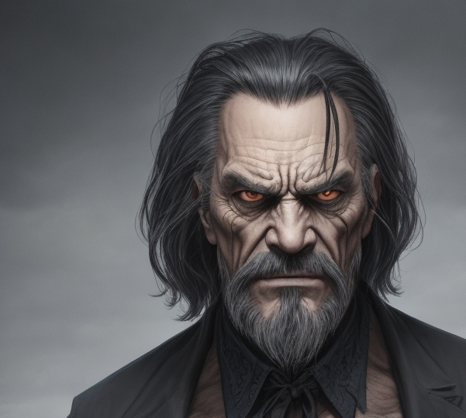
(Seth’s many disguises)

“Despite his brutish and impatient ways, it was not the lord who gave me the hardest time, but as mentioned, Seth, a vile-looking sailor who would visit the lord on a regular basis. Seth's presence loomed over me like a dark cloud, casting a shadow of fear and uncertainty, suffocating me with each passing moment. His very presence gave me the shivers, and I could sense him watching me whenever I moved about the room. Of course, I avoided any room he was in, however, there always seemed to be a reason for the lord and the sailor to want me at their beckon call when the two got together. At times, they would stay up all hours of the night asking for more rum and drink. Meanwhile, my sister was left home fending for herself. One day, she fell sick. Very sick.”

“I knew I had to get some real food into her, so late one evening I grabbed an apron full of vegetables and bread and made my way back home. It was my plan to make her one of those healthy hot stews my mother used to make. The kind that can heal. It didn’t work out that way. The next day and the days to follow were some of the hardest I ever had to endure! Her energy sank, and her eyes became tired. Sunken. The kind of look I saw in my own mother in her final days. Desperate I snuck back to the manor that night and stole a hen.”

“I picked the one that had the worst attitude and gave me the most grief whenever I was collecting eggs. I made my way back to my house. Two hours later they came calling. The sailor named Seth, of course, was the first through the door, while my sister lay ill upon the bed.”

“Soon after a cart pulled by a ragged-looking mule arrived. Not a field cart, loaded with grains, but a box-shaped cart. The kind with the big rusty bars to keep unfortunate people trapped inside. I had seen these before, and it was with a sense of utter despair that I found myself staring at the door closing behind me! The dark sky and stars still sparkling above my head.”

“Wait! I yelled out desperately. My sister…my lord! She’s an amazing cook! You should see her stew! I knew she needed to be in the hands of someone who wanted something from her, if she was going to survive. The lord walked into her room where she lay upon her hay-filled mattress. His angry eyes staring down at her.”

“I yelled through the bars. Sir! She’s the best cook ever! You’ll see! I hollered as the cart bumped its way slowly down the dark lane. I was sure I would never see my sister again!”
“The cold dampness of the city prison cannot be fully explained in words. It eventually became my decision to block out the two years that followed. My misery at hearing nothing of my sister was surpassed only by the loneliness and despair of a cage which knew no season, no sunlight, no joy. Just death. Then, one day, it happened!”
“Come with us! Came to gruff command one morning. The sun had yet to rise, and I stumbled from my corner, wiping sleep from my eyes. Come now, don’t waste! I knew I’d heard that guard’s voice many times before, but it was only later that I realized who my unfortunate savior really was.

Am I to be free? I asked, wrapping my worn blanket around my shoulders. Do you know of my sister Vivian? I begged. The guard grunted and pushed me forward, stealing my blanket. We walked out through the main entrance of the prison to the sunlight as the morning sun crested the hill to the east. It was the first time I had seen sunlight in almost two years! The warmth of the sunlight caressed my skin like a gentle embrace, thawing the icy grip of despair that had held me captive for so long. It was a feeling I will not ever forget.”

“We walked down the cobblestone Lane. My clothes, tattered, wet. More like rags than clothing you would recognize. My hair, unwashed. My appearance elicited stares from passersby, their eyes piercing through me like daggers, while I stood there, feeling exposed and vulnerable. I was humiliated.”

“So, my childhood was not the easiest to say the least. Fending for ourselves in a world where parentless females were considered less than citizens. Of course, I promised my mom before she passed that I would look after my little sister, and you can bet that remained my plan.

The separation when I was pulled aboard a ship headed to the New World created in me an anxiety I can never fully put into words. To add salt to the wound, the crew on board acted like they never saw a woman before. Then he appeared on deck…statue and all! Seth! He smiled as he watched me chained. I should have known! T’was him who had me released! It soon became apparent that he and the captain had some sort of business relationship. However, I wouldn’t call it friendly. They argued constantly. It almost seemed like Seth disliked the captain more than anyone, even me! It was like he was trying to set the captain up for failure! But why?”

“The captain himself sent shivers down my spine. He was a large powerful man with long, dark hair and black, cold eyes. His thick neck rolled down into cruel sloping shoulders, implying he was a man not to be messed with. A cold smile frequently appeared like a smudge across of his face. His dark eyes, evil. He was not a man to be trusted!”

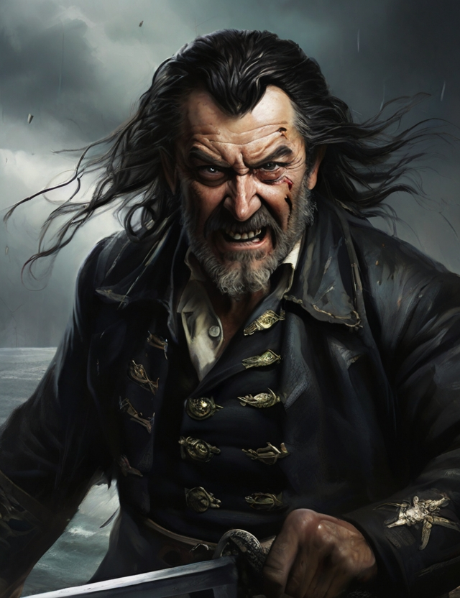
(The Dark Captain)

“The two of them together gave me plenty of reasons to be afraid, however, my sister, and my desire to get back to her, pushed me through those cold, hungry days at sea.”


(Loretta)

“Then, one day, during a quick stop in London, something happened. A stranger arrived on board. He was a young man with a determined look in his eyes. Surprisingly, his very presence seemed to keep everyone on board uneasy, including the captain himself. He chose to ignore me, but I thought there was a light in him. I felt like he was someone I could trust, or perhaps that I had known somewhere, long ago. Later, after a life-changing dip underwater, I would discover I wasn’t wrong. Unfortunately, I wouldn’t find out why until we reached the coastline on the other side of the sea. Why he waited to rescue me on the far side of the ocean is the question I posed to him one day. (After all, I could’ve been off that horrible ship many days earlier!)”
“My rescue. No…my true life, began shortly after our ship landed at a small sandy cove on a cool spring day. Chunks of ice still floated like sea-slush around us. It was foggy, yet I could see the sun struggling to burn through the mist from high above.”
“The yelling began as soon as the anchor was released. I heard it splash from my dark dungeon beneath the deck. We were tired and hungry, having weathered a storm the night before, so many of us had not slept.
Ladies and gentlemen! Bellowed the captain as we were led above decks. There’s been a slight change in plans! He glared down at us from the stern deck. The ice has blocked our intended route up the St. Lawrence! But this bodes well for you all! Look around and see what I offer! Your new home….and freedom! He pointed a cutlass towards the shore, a familiar cruel smile etched across his face.”
“Cruel was an understatement, for we all knew that this was no kind respite. Pure wilderness and rugged cold… surely, we would not survive! We knew nothing of this wild world! A death sentence to many of us perhaps, but one many were willing still to take, me included.”
“You can imagine my horror however, when the first mate Seth alerted me that the captain would be keeping me on board…. with him!”
“That’s the moment the stranger stepped up! Without any forenotice, having quietly observed the whole bizarre ordeal while standing behind Seth, the large blond-haired man yelled towards the captain! Hey cap! I think your first mate has something to show you!”
“Lifting Seth easily, like one does a cat, he raised the screaming man high above his head, further making his way to the side of the ship, yet not before tossing me a small glass vial with a blue liquid inside! Drink this! He had said with a wink as he climbed over the rail. Then, while Seth screamed out…Don’t let him …., the stranger preceded to dive headfirst into the cold sea…with the first mate still in his grasp!”

“I watched in horror, for I knew there was no way either could survive. The dark form of a shark circled in the waters underneath, following the bubbles down into the depths.”
“Then the crew came for me! I stood on the cold, wooden railing, looking to shore. Was this to be my death… my end? I could see no sign of the shark. I did know, however, that what would await me at the hands of the captain would have been much worse!”
“Suddenly I remembered the vial! I bit off the cork and with very little thought, poured the blueish-white liquid into my mouth! Even as I jumped the last of it still poured! Indeed, what a pleasure it was watching the captain scream for me to stop! I could clearly see, as if time stood still, that anger had painted over his smile. I stared at him defiantly as I hurtled downward. I knew he sensed my thoughts, but these soon dissipated to terror as the cold icy water stole my breath away!”
“My wrist and ankle shackles pulled me down so quickly! I looked up to see the feet of many of my shipmates kicking strongly to shore. Still, they too struggled to swim, burdened by their clothes as they were. I watched in horror as some sank in vain beside me.”
“Then, I remember a weird warmth surging from within my stomach. I assumed it was something that happened to people when they were this close to death. I froze, afraid I would open my eyes to a hungry shark, while waiting for deaths’ final blow. Yet it wasn’t death that finally tapped me on the shoulder, but something else. A touch. I held my breath.”
“Strangely enough, that warm glow in my stomach seemed to be telling me something. Implying something I could barely fathom…. that I could breathe now! Common sense however indicated this was to be my end, so I continued to close my eyes, even tighter, holding my breath longer. My feet struggled to find a flat spot to stand up on, amongst the slippery rocks and seaweed. A large piece of coral leaned against my legs, and I balanced myself against it as best as I could. Imagine my surprise when I heard… a voice!”
“Hey you. Came a calm response. You can open your eyes now! That is when my real life began….!”

