Chapter 1- Friends at Sea

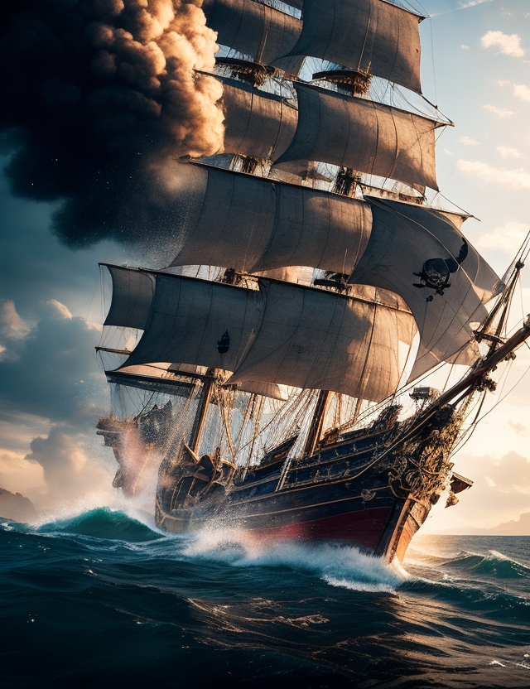

Somewhere off the rugged Cape Breton coast…

The sea glowed with the first blush of sunrise. Jack Barrett leaned on the starboard rail, nerves tightening in his chest as the light grew brighter over the horizon. The air was damp, heavy with salt, and his stomach fluttered with anticipation.
The two exchanged a silent nod. Michel shoved off, and soon they slipped into the half-lit morning. The horizon glowed orange, the water flat and endless.
Jack sat near the stern, hugging his knees. For a moment, he thought of his home under the Halifax piers—dark, damp, but familiar. He almost missed it… until he remembered the gangs that lurked there. Naw, he thought with a grin. I’ll take this place any day.
Michel hoisted a sail that barely caught the light breeze, then rowed, the oars groaning with each pull. They moved steadily away from the ship until it was nothing more than a shadow behind them. Finally, Michel rested his oars and glanced at Jack.
Don’t worry, mon ami. Your adventure begins today. And you ‘ave company.
Jack frowned. Company? What do you mean by—
The sea exploded beside them. A figure shot out of the water, seaweed streaming like battle flags. Huge, glassy eyes glared at Jack as the creature heaved itself onto the boat. The skiff pitched violently. Jack toppled off his bench, throwing his arms over his face. Whoa!
A laugh rang out. Hello, you!
The “monster” ripped away her seaweed disguise, tossing it back into the waves! It was Loretta—the mysterious mergirl with long black hair plastered across her face, grinning like she’d pulled the prank of the century.
Jack peeked through his fingers, trying not to look too rattled. Loretta? Hey! But how did you get—
Well, how did you? she cut in, smirking. I swam, of course!
Jack felt his cheeks heat. Embarrassed, thrilled, maybe even a little annoyed, he wasn’t sure which. Michel, meanwhile, nearly fell overboard laughing, slapping the side of the boat in hysterics. Jack grabbed a lump of seaweed and hurled it at him.
So you knew about this too, eh?
Although it had been only a few days since Jack had last seen Loretta, it felt like weeks. Soon the three were deep in conversation, catching up quickly. Jack finally leaned back, narrowing his eyes at them both. Alright then… why are you two here? And more importantly—how do you know each other?
Loretta’s eyes sparkled with mischief. Well, this big oaf here fell overboard one day. I couldn’t just let the fish eat him, could I? So I fished him out.
Michel blushed, scratching the back of his neck. Oui… she ‘elped me, that’s for sure. Thought I was done for, but she lifted me into my bateau like I was a minnow.
Loretta shrugged. We started talking. Since then, he’s been my eyes and ears on the land.
Jack studied them as they joked, feeling an unexpected stab of jealousy. Well, he said awkwardly, things are looking up more every day. Count me in. What’s next?
The mermaid and the fisherman traded a glance, then turned to Jack with the same sly grin. You are, they said together.

That same morning, back aboard the Flounder, a young woman stepped off the gangplank into the misty streets of Louisbourg. Hannah’s brown hair whipped in the sea breeze as her skirts swirled around her boots. Two gray-clad soldiers stood guard at the gate, their postures stiffening as she approached. Their muskets gleamed in the fog.
Bonjour, messieurs, Hannah said sweetly. Parlez-vous anglais?
One of the soldiers lifted his hand, pinching his fingers together. Un peu… a little.
Très bien, she replied with a polite smile. I am looking for the Governor. And… for information about my father. He was French. Perhaps you know of him?
The soldier raised an eyebrow. Perhaps. What is his name?
Hannah hesitated, her voice quiet but firm. Duc d’Anville.
The soldiers froze. They exchanged a glance of disbelief. Duc? one whispered.
Oui. Duc, Hannah repeated, though her stomach twisted at their reaction.
Her mother had told her stories of her father—an adventurous, charming man she’d met along the Halifax waterfront. But the stories were vague, sometimes contradictory, as if even her mother wasn’t sure she’d known him at all. All Hannah knew was that he had died young, supposedly from an injury.
One of the soldiers extended an arm. Come with us.
Hannah hesitated only a second before taking it. The moment her hand touched his sleeve, her path shifted forever.
They guided her through the streets. Soldiers prepared for inspection at Place Royale—polishing muskets, straightening uniforms, even ironing wrinkles from their coats with heated irons. Hannah felt dozens of eyes on her as she passed, her cheeks warm.
At last, they climbed a hill toward a walled enclosure. Another officer greeted them. After a quick exchange, the guards bowed and left Hannah standing alone. Moments later, a heavy wooden door groaned open.
Madame d’Anville, a voice announced. The Governor wishes to welcome you… to the King’s Garden.



Hannah stepped inside. Lavender, spices, and flowers filled the air. A gardener bowed, then disappeared among the blooms. From deeper in the garden, a figure emerged: a short man in a gray wig, leaning heavily on a wooden leg. His cheeks were red and swollen, his eyes watery. In one hand, he clutched a pewter cup stamped with a bold carving of the sun. The liquor inside was sharp enough to sting Hannah’s nose from several feet away.
She curtsied, biting her lip.
The man studied her carefully. Governor Jean-Baptiste-Louis Le Prévost Duquesnel, he said, bowing stiffly. His puffy gray eyes gleamed with something between curiosity and suspicion. What brings you to our little fort, my lady?

