The Mola Mola
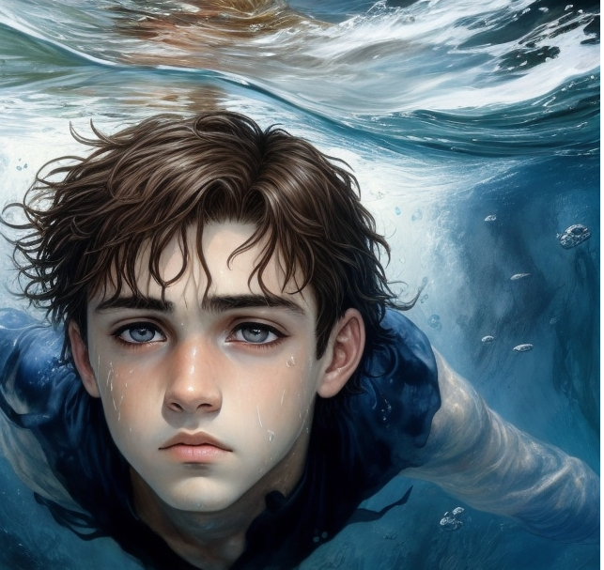
A long time ago, when I was but a young child my grandfather told me this amazing story.
This timeless incident happened over a century ago, however during its telling, it seemed to me that my grandfather thought it had just happened. I remember my grandfather’s smiling eyes most of all….
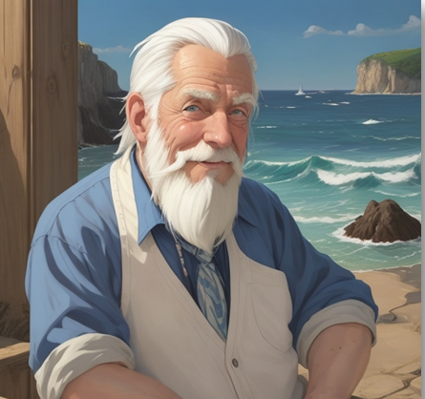

They were the color of the bluest ocean, and, true to form, during this story, they sparkled not only with kindness, but with gratitude. He had a contagious laugh and a love of life. Little did I know, I’d understand him even better by the end of this…. his story.
If you haven’t heard this tale…. then perhaps it’s time you did, for this is one of those stories that just must be shared…. and remembered.



Chapter 1 – At Sea! 

There once lived a young boy named Fraser. He lived in a tiny fishing village on Cape Breton Island. One day, when he was only nine, his father decided it was time for him to leave school and join the family trade... fishing. Around here, that’s just what boys did.
So, Fraser packed up his books, said goodbye to his classmates, and promised himself he’d make his father proud.
That night, he went to bed early, excitement buzzing in his chest. Tomorrow would be his very first day at sea!
It felt like he had only just closed his eyes when a hand shook his shoulder.
Time to go, buddy, his father whispered before walking down the narrow staircase to the kitchen below.
Fraser blinked at the dark window. The stars still glittered outside. Morning had not yet come.

Fraser peered anxiously out the small bedroom window. It was four in the morning, and the night sky still sparkled with stars as he wiped the sleep from his tired eyes. The boy obediently crawled out of bed, put on baggy pants and a faded shirt, and made his way wearily downstairs.
After a quick breakfast of bread, molasses and tea, Fraser slipped his feet into a set of large rubber boots. He gave his mother a hug, grabbed his lunch box, and began the dark trek down to the shore.
As he walked, the boy plodded through black, mud-lined puddles. Even the songbirds had yet to begin their morning chorus, leaving only the stars to twinkle a morning greeting to the boy.
Fraser skirted the puddles now, growing tired of the mud as they pulled at his oversized boots. At times, he almost lost his boot entirely!
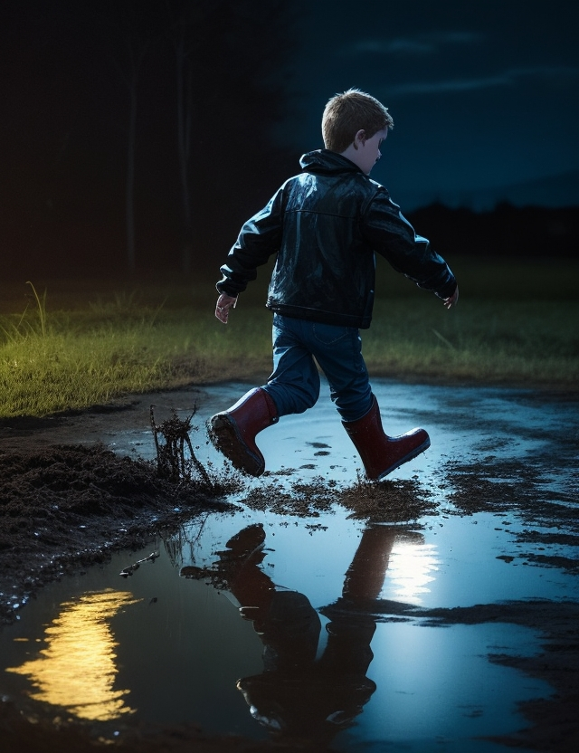
The dimly lit road, little more than a path, finally ended among the beach grass near the shore. Fraser could see the white light at the back of his fathers’ fishing boat, tied to the wharf. He could also hear the impatient chugging of the motor as barrels of bait were being loaded on-board by his father.
Crossing over the log-covered wharf, he climbed down onto the side of the boat. He had done this many times before, but this time, something felt very different.
Fraser reached up, released the lines, and soon father and son joined the small fleet of boats making their way seaward out of the bay.
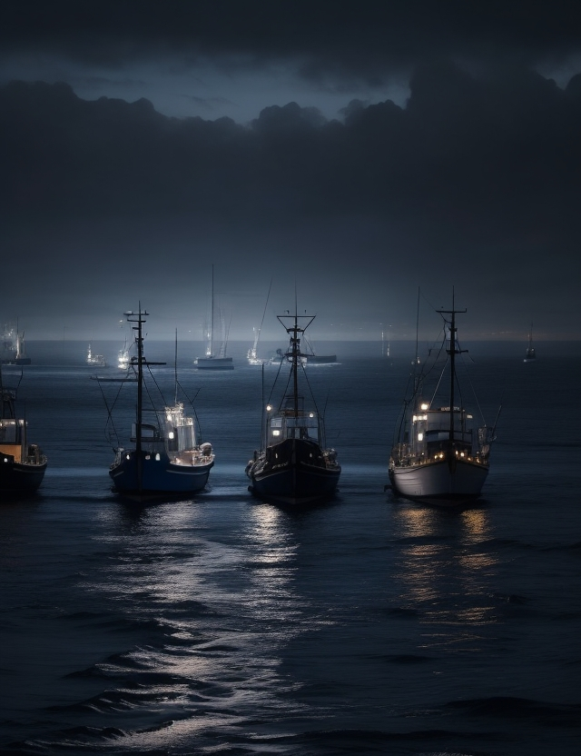
After a while the sun rose, revealing a beautiful day, with calm seas and gentle winds.
At sea, Frasers’ job was simple, and he soon found himself trying to entertain his mind as the boat weaved from trap to trap. Using a long stick with a hook tied to the end, called a gaff, his job was to reach over the side of the boat and hook the red buoys that marked his father’s lobster traps. After this his father would raise the traps by hand, and the two of them would reach inside to pull out all the lobsters, crabs, sea urchins and starfish that had gotten trapped inside. All would be thrown back overboard, except for the lobsters. These Fraser would peg, throw in a box, and then he’d rebait the trap with a piece of fish for the next day.
Finally, when each trap was ready, Fraser would wait for his father’s command and push the heavy trap, rope, and buoy, back into the sea.
This routine continued well after the sun had risen in the sky, and although it became tedious, Fraser found time to admire the coastal wildlife that flourished everywhere around him.
Then, it happened! After Fraser had finished baiting the seventy-fifth trap, he noticed a large gray fin and eyeball, sticking out of the water nearby!
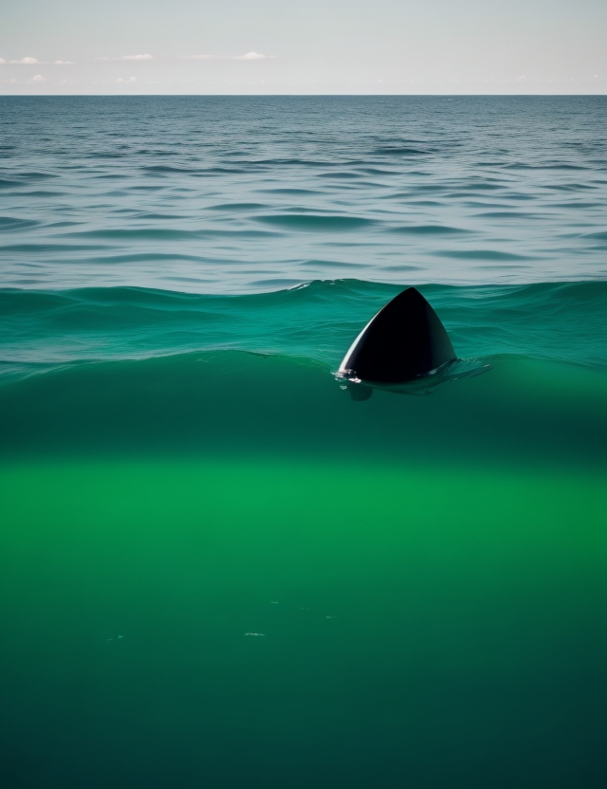
Father… look! What’s that? Shouted Fraser. It was without doubt the strangest creature Fraser had ever laid his eyes on!
It’s twice as big as our kitchen table! Yelled Fraser over the roar of the engine. Indeed, the creature was large, unusually so, at eighteen feet from head to its stubby tail!
The fish stared quietly skyward. It floated on the surface, as if soaking in the warm afternoon sun. It’s one big eye suddenly looked directly at them as they chugged slowly by.
Yup. That’s a mola mola, son. Said his father. The fishermen here call it a sunfish!
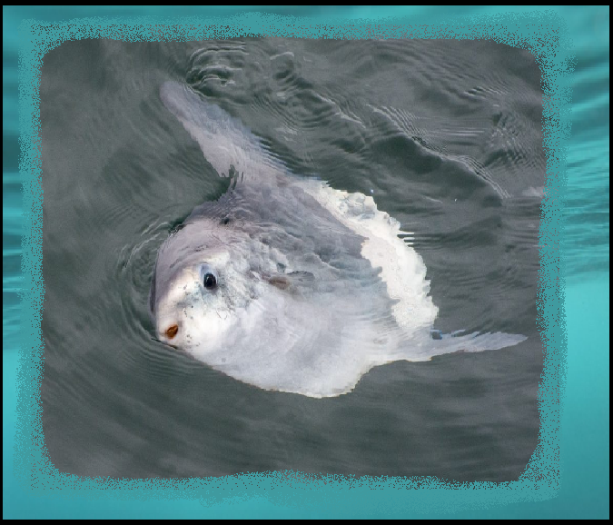
Fraser stared in wide-eyed wonder. Wow! Do we eat them? Or maybe I should ask….do they eat us? He asked curiously.
Definitely not! Laughed his father. Their very bony, and quite harmless, so we just leave them alone. I’m surprised we managed to get this close to one, since they also prefer to be left alone.
As Fraser stared in wide-eyed wonder at the huge fish, his father continued with a wink….
You’ve got good eyesight though son, but let me know if you see a tuna or swordfish next time will you!
That was that. The time for talk had ended. The old engine continued to chug steadily on by, and Fraser soon realized there wasn’t a lot of time to play when the business of fishing was at hand.
Here comes another trap! Shouted his dad. Fraser quickly scooped up his gaff and rushed for the next buoy.
As he cleaned the trap, the boy’s eyes scanned the water for his newfound friend, however the fish was nowhere to be seen.
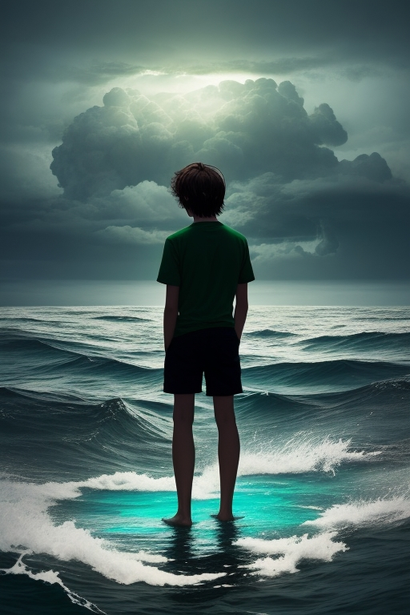

Ok, let ‘er go now! Yelled his father over the rumble of the engine as he turned to grab the steering wheel. Fraser pushed the heavy wooden trap back into the sea. Again, he searched for signs of the fish in the water.
Suddenly, as if awoken from a trance, Fraser looked down to see the buoy he had forgotten to throw over! Instantly he reached down to grab it, but in doing so, noticed something which made his heart stop! The rope, which was attached to the trap he had just thrown over, was now double wrapped around his boot!
Fraser looked desperately back at his father for help! Dad! Was all he had time to say. Then, in the blink of an eye, the boy was pulled quickly into the sea!
The weight of the trap dragged poor Fraser mercilessly down under, as the ice-cold water seeped into his baggy clothing.
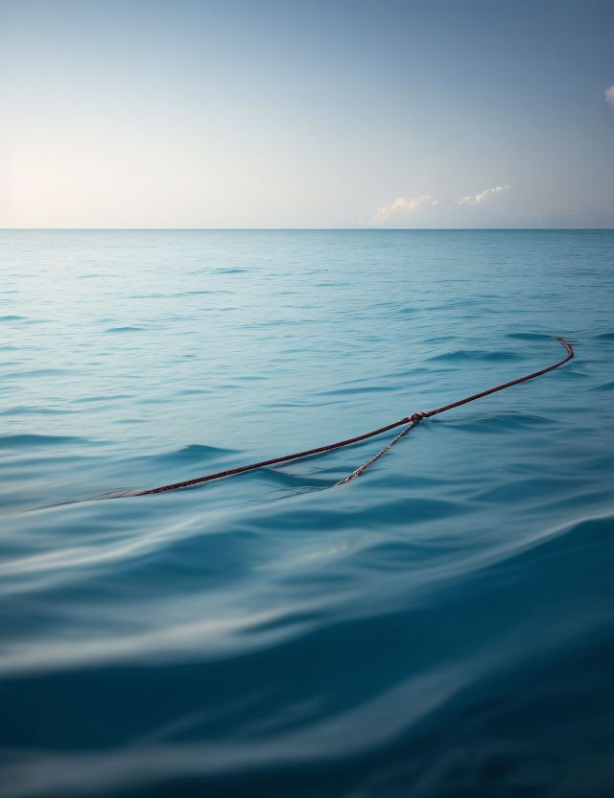
Fraser could do nothing but look up to the surface to see the suns’ light reflecting farther and further way! Helpless, he continued to sink deeper into the cold waters of the Atlantic!

