Chapter 1- The Bay

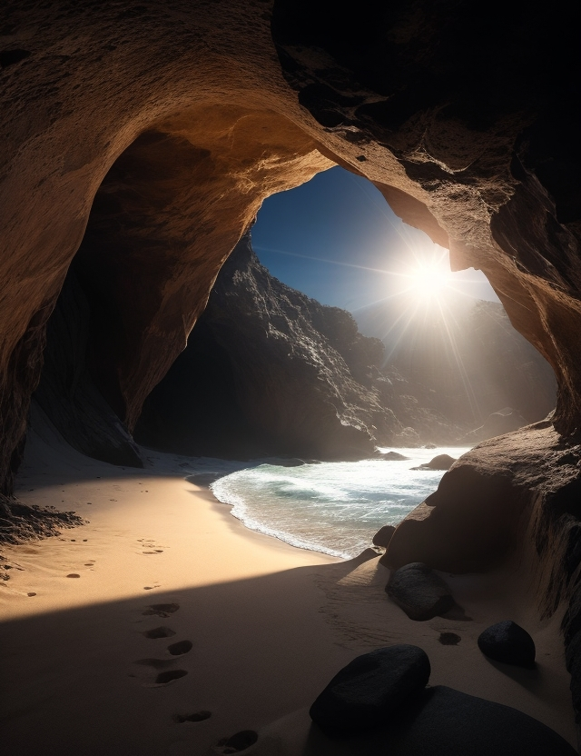

The world as we know it sometimes tricks us into thinking it’s boring, predictable, and flat. But there are people—those who feel every ripple of the sea breeze and every whisper of the waves—who know differently. Shannon, at first, was not one of them.
Our story begins on a summer day that looked ordinary enough.
Far out in the harbour, a seal’s head bobbed above the salty water, its black eyes glinting like polished stones. Deep below, two sleek figures swam upward, their tails slicing the blue depths with effortless speed.
Déjà vu again, Mira, Noah muttered, flicking his tail nervously.
Mira rolled her eyes, her red hair streaming like a banner behind her. You say that every time we pass the Flemish Cap. It’s not exactly original, you know.
Still. Something feels strange. Stranger still when we go ashore, he said.
She grabbed his hand, her webbed fingers cool against his. Relax, land-born. You’ll survive. Probably.
So, this kid—we’re sure he’s a teenager? Noah asked.
That’s the one, Mira said. And even Seth has noticed him. Which means we’d better hurry.
With a surge of speed, they cut through the water. Fish scattered. Spray rose in silver arcs behind them.
Race you to Shut-In Island, Noah challenged, darting forward.
Mira shot past him, leaping high into the air before crashing down ahead. Try to keep up, land-boy, she teased.
The granite cliffs of Shut-In Island loomed on the horizon.
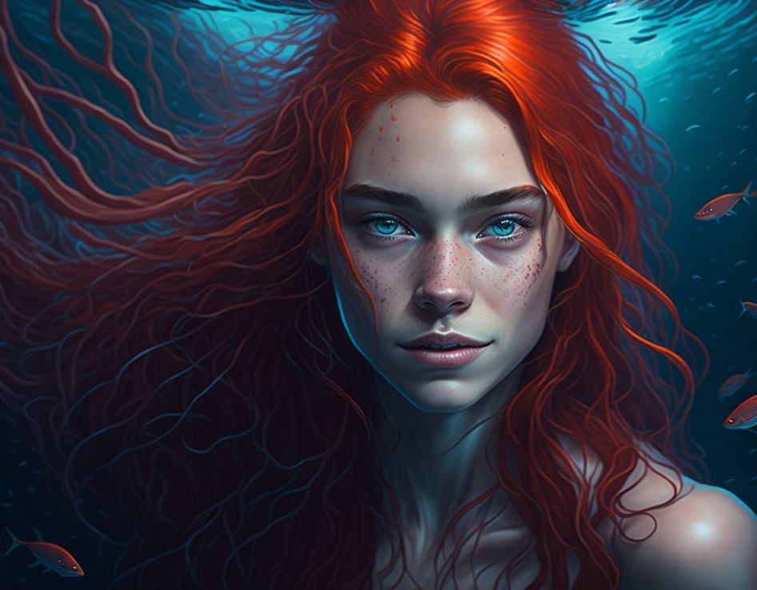

Closer to shore, an old gray seal surfaced, whiskers dripping. At eight feet long and heavier than a small car, he was a giant of St. Margaret’s Bay. But even giants know when danger is near.
The seal cracked a razor clam between his teeth. Crunch. The sound echoed across the fog. Then a red fishing boat slowed, drifting too close.

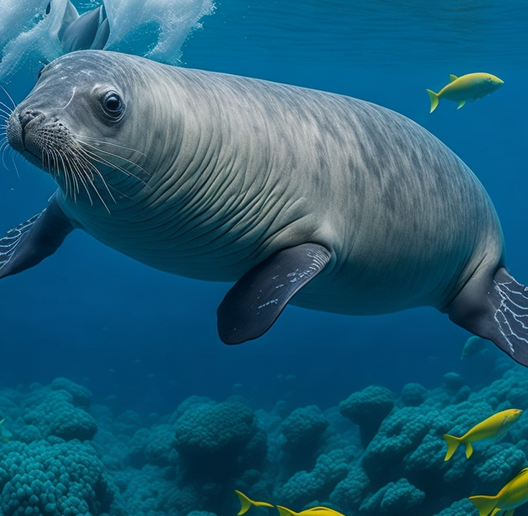
The old seal didn’t wait. He dove deep, just as a gunshot blasted the water’s surface. Bubbles trailed behind him as he swam into the shadows. When he finally surfaced far away, the fisherman circled above, scanning the waves. But when he reached for his gun, the weapon was gone.
Along the shore, Shannon Barrett sat at the edge of his family’s wharf, dipping his bare feet into the icy Atlantic. Yep, he thought, this is the good life: me, the sea, and absolutely no friends to bother me.
It wasn’t that he hated people. He just… didn’t have any. Not since his dad disappeared two years ago.
From his perch, he watched boats crisscross the bay. Kayaks impressed him most—the way their paddlers cut through waves like knights on quests. Sleek, fast, impossible to tip over. To Shannon, kayaks meant freedom. And he could definitely use some of that.
A sudden splash made him jolt upright.
A seal surfaced—no, not just a seal. The biggest seal in the history of seals. Its dark eyes locked onto him, unblinking.
Okay, Shannon thought, either I’m about to be eaten, or I just made my first friend in, like… forever.
The seal inhaled, loud and wheezy, like Darth Vader at a dentist’s office. Shannon couldn’t help but grin.
The two stared at each other. Boy. Seal. No words. Just silent, awkward bonding. Every few minutes, the seal surfaced again, closer each time, like it was checking him out.
Then a motorboat growled into the cove. With a mighty splash, the seal vanished.
Shannon flopped back onto the grass, arms crossed. Figures. Even seals ditch me when other people show up.
He stared across the bay, trying not to think about how empty things felt without his dad.

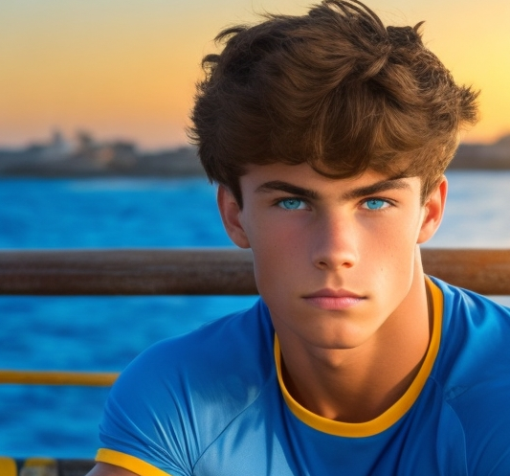

Once, winters meant movie nights. He and his father on the old leather couch, popcorn in their laps, the fire crackling. They watched everything: Moby Dick, submarine thrillers, pirate adventures. Afterwards, his dad would pull out old maps, tracing secret coves where real buccaneers once hid treasure.
Shannon loved those nights. But two years ago, they ended. His father’s ship sailed from Halifax—and never returned.
The memory hit sharp and clear. His mother on the wharf, begging: Ron, tell me this is your last trip.
Last one. I promise, his father had said.
He lied.
They claimed he fell overboard. But Shannon didn’t buy it. His dad was a Navy diver. He could swim in his sleep.
Since then, Shannon had pulled inward. No siblings. No friends. Just his mom, Beryle. She tried- walks by the water, running her fingers through his hair, whispering that his father still loved him. She listened to the sea like it was whispering back. But Shannon never heard a thing.
Still, he hoped.
Maybe his dad was alive somewhere. Maybe a ship would return him one day, carrying maps, laughter, and way too much popcorn.
His mom hoped too. She never said otherwise.
But time was ticking. And with it came danger—danger neither of them could imagine

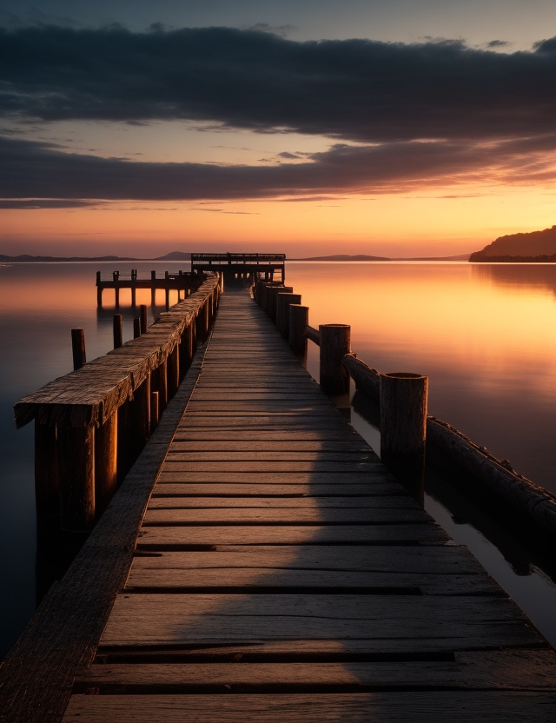

Back in the bay, guided by its large whiskers and amazing sense of smell, the same seal hung suspended upside down in the clear water. Long strands of kelp swayed like snakes from the seabed around him. A lobster futilely attempted to back itself deeper and deeper into an underwater crevice, however it soon ended up in the jaws of the hungry seal. Yet, the seal seemed to be having a hard time moving today. It’s back throbbed painfully in the cold waters.
Then he sensed something. A shift in the current. A presence moving fast.
The seal hauled himself onto a rock, eyes fixed on the depths. His tired body trembled—then suddenly surged with new strength, as though something ancient had awakened within him.

