Chapter 1-The Gray!



Many years ago, in a small fishing community in Cape Breton, Nova Scotia, there lived a kind old man named Fraser. I knew him well, for he was my grandfather.
His village, Little Lorraine, was located along a rugged stretch of coastline. Fog, sun, wind, and rain were frequent visitors, yet the weather was embraced by the rugged people who lived there. It was indeed a wild coastline. To feed his family, Fraser fished for all kinds of fish, however the biggest rewards came from swordfish.
Fraser was also getting on in years and his fishing days were coming to an end. This is when I came along….



My grandfather needed help fishing and my parents, who also needed help raising four gregarious children, decided it would serve everyone well if I was sent to help him out.

The end of the school year arrived, and sure enough, I was shipped off kicking and screaming, only to end up in this small fishing village for the summer. I resented the move, instead wishing I was back home with my family and friends. As time went by, despite the early morning wake up calls and seasickness, I eventually grew to love the time my grandfather and I spent together.



One day, at the curious age of nine, I noticed a long wooden spear tied loosely along the side of our boat, named the Beryle & Michelle.
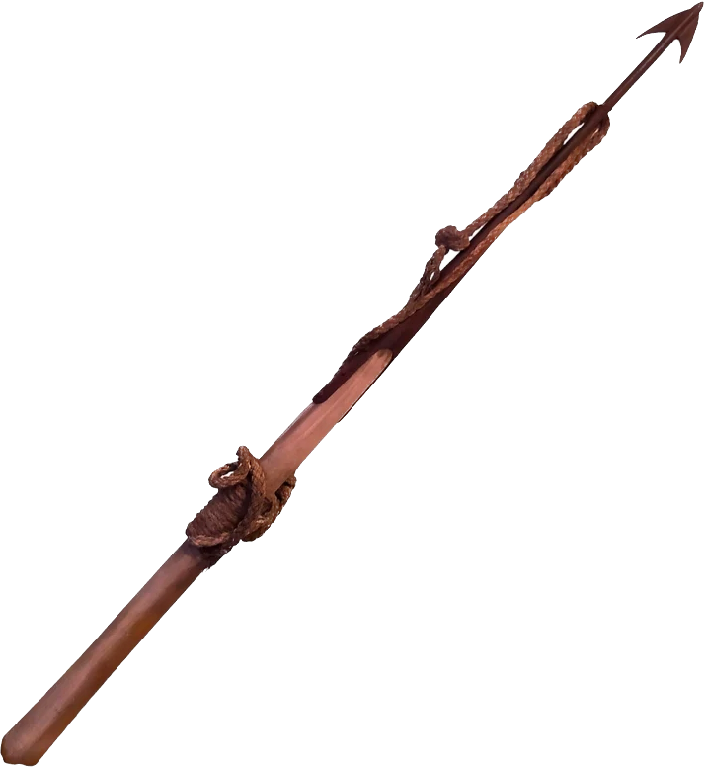
What’s this for? I asked curiously. Gramp looked at it, then back at me. Just my ol’ swordfish spear. He answered quickly. I looked up at him to see what he meant by this, but he seemed distracted, an odd, distant look engraved on his weathered face. I guessed immediately that there was more to this story than just the spear, particularly since he stood in a trance-like state, as if unaware I was even there. The next day, I would discover, I wasn’t wrong!
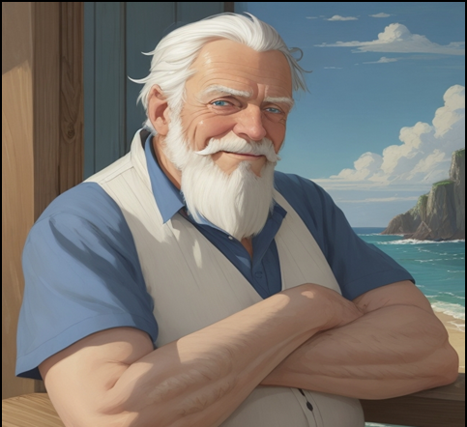

It was suppertime. We sat at the kitchen table eating a meal of salt cod, and potatoes, when I first heard about the swordfish. I remember how his eyes sparkled blue in the telling of this story in contrast to his ruddy weathered skin. Fortunately, despite my grandfather’s advanced age, his mind remained as sharp as his eyes. I settled in, prepared to listen as I finished up my meal.

Gramp, (As I called him) often told me many stories and fables about the ones that had gotten away, and with unequalled enthusiasm, I listened to them all. However, this yarn wasn’t just a bedtime story. Its details were crisp and real. Hence, I learned a truly remarkable story about my grandfather, and, a larger than life swordfish. A fish that, for years could never be captured. This giant beast was respectfully known to the locals as The Gray!
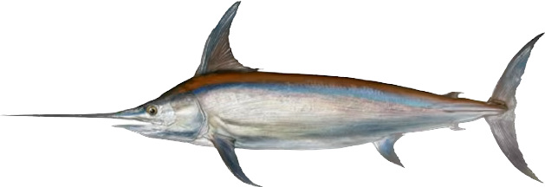
Now, according to Gramp, to be a sword-fisher, a person had to have a few very important skills. Excellent eyesight, and great aim. (From what the locals said, Gramp had both.)
His story began like this….

Robbie….one late Sunday afternoon, many years ago, a man named Shannon arrived from a nearby village. He was the captain of a schooner, a sword fishing boat with sails and a crew of five. He arrived that day to see me about a problem he was having... It had to do with swordfish…. or should I say, lack of swordfish!
So, we had tea in this here kitchen, nibbled on hot biscuits dipped in molasses, and talked of the weather. However, no sooner had the captain finished eating, then a serious look spread upon his face….
“Fraser.” He said. “With the weather being bad and all… I’m afraid I need your help. One of my men is sick and we must get out before the weather turns worse. We’ve had a horrible season as you know…and now’s our last window for swordfish! I can’t do it without ya!” He pleaded.
So, my grandfather, saddened to see the man in such a desperate situation, with a family of his own to support, reluctantly offered to help….
This is his story….

Four o’clock the next morning, my grandfather woke up, and after making his way down to the beach, loaded his gear on board a fifty-foot sword-fishing schooner. It had been ten years since he had last gone to sea.
My grandmother, Loretta, was there to see him off….as usual. She was the love of his life, yet he gave her but a quick goodbye kiss since it hurt him to see that old familiar worry in her proud gray eyes. They watched each other until the ship carried him far out to sea.

